**Anjuman-I-Islam’s**

M.H. Saboo Siddik Polytechnic

8, M.H. Saboo Siddik Polytechnic Road, Mumbai, 400008



SECOND YEAR DIPLOMA IN COMPUTER ENGINEERING

(2022-23)

PROJECT REPORT ON

**ONLINE FOOD DELIVERY APP**

By

210451- Abdurrahman Qureshi

210453- Ansari Saad

210460- Arya More

210463- Adnan Kazi

UNDER THE GUIDANCE OF

**Mrs. Farhanaaz Sayed Ma’am**



Maharashtra State Board of Technical Education (MS-BTE)



**MAHARASHTRA STATE**

**BOARD OF TECHNICAL EDUCATION**

**Certificate**

This is to certify that Mr. Abdurrahman Qureshi Roll no. 210451 of fourth semester of Diploma in Computer Engineering of institute M.H. Saboo Siddik Polytechnic (code: 0002) has completed micro project satisfactorily in the subject: SEN (22413) for the academic year 2022-23 as prescribed in the curriculum.

Place: Byculla, Mumbai Enrolment no:2100020112

Date: ______________ Exam seat no:

Signature Signature Signature

Project guide H. O. D Principal

SEAL OF

INSTITUTE



**MAHARASHTRA STATE**

**BOARD OF TECHNICAL EDUCATION**

**Certificate**

This is to certify that Mr. Ansari Saad Roll no. 210453 of fourth semester of Diploma in Computer Engineering of institute M.H. Saboo Siddik Polytechnic (code: 0002) has completed micro project satisfactorily in the subject: SEN (22413) for the academic year 2022-23 as prescribed in the curriculum.

Place: Byculla, Mumbai Enrolment no:2100020102

Date: ______________ Exam seat no:

Signature Signature Signature

Project guide H. O. D Principal

SEAL OF

INSTITUTE



**MAHARASHTRA STATE**

**BOARD OF TECHNICAL EDUCATION**

**Certificate**

This is to certify that Mr. Arya More Roll no. 210460 of fourth semester of Diploma in Computer Engineering of institute M.H. Saboo Siddik Polytechnic (code: 0002) has completed micro project satisfactorily in the subject: SEN (22413) for the academic year 2022-23 as prescribed in the curriculum.

Place: Byculla, Mumbai Enrolment no:2100020097

Date: ______________ Exam seat no:

Signature Signature Signature

Project guide H. O. D Principal

SEAL OF

INSTITUTE



**MAHARASHTRA STATE**

**BOARD OF TECHNICAL EDUCATION**

**Certificate**

This is to certify that Mr. Adnan Kazi Roll no. 210463 of fourth semester of Diploma in Computer Engineering of institute M.H. Saboo Siddik Polytechnic (code: 0002) has completed micro project satisfactorily in the subject: SEN (22413) for the academic year 2022-23 as prescribed in the curriculum.

Place: Byculla, Mumbai Enrolment no:2100020117

Date: ______________ Exam seat no:

Signature Signature Signature

Project guide H. O. D Principal

SEAL OF

INSTITUTE

**Acknowledgment**

We wish to express our profound gratitude to our guide Mrs. Farhanaaz Sayed Ma’am who guided us endlessly in the framing and completion of the micro project. She guided us on all the main points in that micro project. We are indebted to his/her constant encouragement, cooperation, and help. It was his/her enthusiastic support that helped us in overcoming various obstacles in the micro-project. We are also thankful to our Principal, HOD, faculty members and classmates of Computer Engineering department for extending their support and motivation in the completion of this micro-project.

Names of Team Members with Roll Nos.

1. Abdurrahman Qureshi – 210451
2. Ansari Saad – 210453
3. Arya More – 210460
4. Adnan Kazi – 210463

**Annexure-I**

***Micro project proposal***

**Title of micro project: ONLINE FOOD DELIVERY APP**

1. **Aims/Benefits of micro project**

Software Engineering is the foundation for professional processes to be followed involving principles, practices and techniques for software development. This project aims to make a software based on the problem statement. Identifying scope of project, selecting relevant process models, preparing ER diagrams and use case models. Benefit mainly will be making us independent enough to develop a software.

1. **Course outcomes addressed**

* Select suitable Software Process model for software development
* Prepare software requirement specification.
* Use software modelling to create data designs.
* Estimate size & cost of software product.
* Apply project management and quality assurance principles in software development.

1. **Proposed methodology**
2. To search the information about the project. (Collect relevant data from different sources i.e. books/internet and others through surveys/interviews etc.).
3. To collect all relevant content / materials to complete the project.
4. To prepare the report of micro project.
5. To prepare presentation.
6. To deliver presentation/ appear for viva-voice
7. Discussion of the given topic among group members.
8. Literature survey
9. Submission of project proposal
10. Analysis of data
11. Work divided among group members
12. Compilation of content
13. Representation
14. Editing the content as per the instructions
15. Report Preparation
16. Viva and presentation

***Annexure-I***

#### IV. Action Plan

|  |  |  |  |  |
| --- | --- | --- | --- | --- |
| **Weeks** | **Details of activity** | **Planned start date** | **Planned finish date** | **Name of responsible team members** |
| 1& 2 | Discussions & finalization of topics |  |  |  |
| 3 | Preparation of abstract |  |  |  |
| 4 | Literature review |  |  |  |
| 5 | Submission of Micro-Project proposal(Annexure -I) |  |  |  |
| 6 | Collection of information on given topic |  |  |  |
| 7 | Collection of all relevant contents |  |  |  |
| 8 | Discussion and submission of outline of the project |  |  |  |
| 9 | Analysis/execution of collected data/information and Preparation of prototypes/drawings/charts/graphs/ tables/models/circuits/programs etc. |  |  |  |
| 10 | Compilation of contents of project |  |  |  |
| 11 | Compilation of weekly progress report |  |  |  |
| 12 | Preparation of the project report (Annexure II) |  |  |  |
| 13 | Viva Voce / Delivery of presentation. |  |  |  |

#### V. Resources required

|  |  |  |  |  |
| --- | --- | --- | --- | --- |
| **Sr. no.** | **Name of resources** | **Specifications** | **Qty** | **Remarks** |
| 1. | Online | Learning resources and various websites | 5 sites |  |
| 2. | Desktop | Microsoft word, Tools with internet facility. | 1 for each |  |

Names of Team Members with Roll Nos.

1. 210451 Abdurrahman Qureshi

2. 210453 Saad Ansari

3. 210460 Arya More

4. 210463 Adnan Kazi

Approved by:

Sign of Faculty:

Name of faculty: Mrs. Farhanaaz Sayed

1. **Literature Review**

In COCOMO, projects are categorized into three types:

* Organic
* Semidetached
* Embedded

1.Organic: A development project can be treated of the organic type, if the project deals with developing a well-understood application program, the size of the development team is reasonably small, and the team members are experienced in developing similar methods of projects. Examples of this type of projects are simple business systems, simple inventory management systems, and data processing systems.

2. Semidetached: A development project can be treated with semidetached type if the development consists of a mixture of experienced and inexperienced staff. Team members may have finite experience in related systems but may be unfamiliar with some aspects of the order being developed. Example of Semidetached system includes developing a new operating system (OS), a Database Management System (DBMS), and complex inventory management system.

3. Embedded: A development project is treated to be of an embedded type, if the software being developed is strongly coupled to complex hardware, or if the stringent regulations on the operational method exist. For Example: ATM, Air Traffic control.

For three product categories, Bohem provides a different set of expression to predict effort (in a unit of person month) and development time from the size of estimation in KLOC (Kilo Line of code) efforts estimation takes into account the productivity loss due to holidays, weekly off, coffee breaks, etc.

**What is a Gantt chart?**

A Gantt chart is a project management tool that illustrates work completed over a period of time in relation to the time planned for the work. It typically includes two sections: the left side outlines a list of tasks, while the right side has a timeline with schedule bars that visualize work. The Gantt chart can also include the start and end dates of tasks, milestones, dependencies between tasks, and assignees.

1. **Waterfall Model:**

The waterfall model is a software development model that follows a linear, sequential approach to software development. In this model, the development process is divided into discrete phases that must be completed in order before the project can move on to the next phase. The phases of the waterfall model typically include:

* Requirements gathering and analysis
* System design
* Implementation (coding)
* Testing
* Deployment
* Maintenance

The waterfall model assumes that each phase is distinct and that the output of each phase is a prerequisite for the subsequent phase. This means that once a phase is completed, it cannot be revisited without going back to the beginning of the project. The advantages of the waterfall model include its simplicity, its ability to provide a clear structure for development, and its emphasis on documentation.

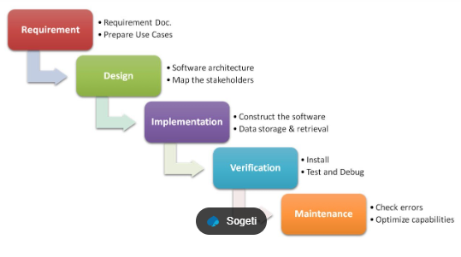

1. System Design − The requirement specifications from first phase are studied in this phase and the system design is prepared. This system design helps in specifying hardware and system requirements and helps in defining the overall system architecture.
2. Implementation − With inputs from the system design, the system is first developed in small programs called units, which are integrated in the next phase. Each unit is developed and tested for its functionality, which is referred to as Unit Testing.
3. Integration and Testing − All the units developed in the implementation phase are integrated into a system after testing of each unit. Post integration the entire system is tested for any faults and failures.
4. Deployment − Once the functional and non-functional testing is done; the product is deployed in the customer environment or released into the market.
5. Maintenance − There are some issues which come up in the client environment. To fix those issues, patches are released. Also to enhance the product some better versions are released. Maintenance is done to deliver these changes in the customer environment.

* Advantages:
* Simple and easy to understand and use
* Clearly defined stages.
* Well understood milestones.
* Easy to arrange tasks.
* Process and results are well documented.
* Disadvantages:
* High amounts of risk and uncertainty.
* Not a good model for complex and object-oriented projects.
* Poor model for long and ongoing projects.

1. **Incremental model:**

* Incremental Model is a process of software development where requirements divided into multiple standalone modules of the software development cycle.
* In this model, each module goes through the requirements, design, implementation and testing phases. Every subsequent release of the module adds function to the previous release.
* Phases of incremental model:

1. **Requirement analysis:** In the first phase of the incremental model, the product analysis expertise identifies the requirements. And the system functional requirements are understood by the requirement analysis team. To develop the software under the incremental model, this phase performs a crucial role.
2. **Design & Development:** In this phase of the Incremental model of SDLC, the design of the system functionality and the development method are finished with success. When software develops new practicality, the incremental model uses style and development phase.

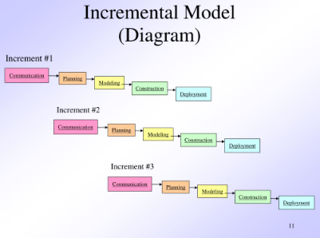

1. **Testing:** In the incremental model, the testing phase checks the performance of each existing function as well as additional functionality. In the testing phase, the various methods are used to test the behavior of each task.
2. **Implementation:** Implementation phase enables the coding phase of the development system. It involves the final coding that design in the designing and development phase and tests the functionality in the testing phase. After completion of this phase, the number of the product working is enhanced and upgraded up to the final system product.

* Advantages:
* Easier to test and debug
* More flexible.
* Simple to manage risk because it handled during its iteration.
* Disadvantages:
* Need for good planning
* Total Cost is high.
* Well defined module interfaces are needed.

1. **Agile Process Model**

* The meaning of Agile is swift or versatile. ‘**Agile process model’** refers to a software development approach based on iterative development.
* Agile methods break tasks into smaller iterations, or parts do not directly involve long term planning.
* The project scope and requirements are laid down at the beginning of the development process. Plans regarding the number of iterations, the duration and the scope of each iteration are clearly defined in advance.
* Each iteration involves a team working through a full software development life cycle including planning, requirements analysis, design, coding, and testing before a working product is demonstrated to the client.
* It has small but dedicated teams with high degree of synchronization.

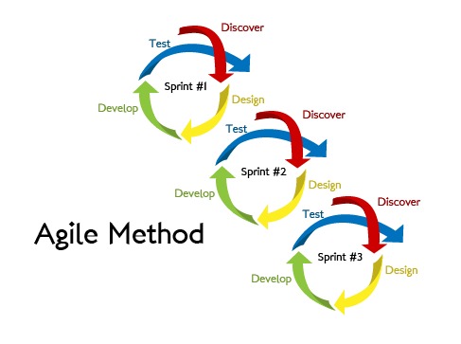

* **Features of Agile Process Model:**

1. Simplicity is essential
2. Project is developed around motivated individuals
3. Welcoming changing requirements
4. Close & daily cooperation between business people and developers.
5. Face to face communication takes place
6. Continuous attention to technical excellence and good design.

* Types of agile modelling include: SCRUM, eXtreme Programming (XP), Crystal, Dynamic Software Development Method (DSDM), etc.

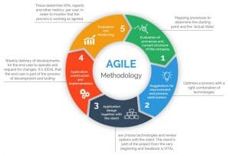

* Advantages:
* Improved project predictability and flexibility
* High team morale
* Face to face communication with clients.
* Disadvantages:
* Lack of necessary documentation
* Maintainance problems

***PROCESS MODEL USED FOR FOOD DELIVERY SYSTEM:***

* We have selected ‘Waterfall Model’ for our project as it follows sequential approach.
* An entire plan has been laid down and new process begins after completion of one process.
* Our process begins with software requirement and customer specification and processes through planning & testing.
* Process flows from top to bottom like flow of water from hill to ground. It is pre-planned in nature.
* Any new changes can’t be incorporated in middle of project development.
* Product of this model always defines all constraints of organization.
* ‘Waterfall model’ produces a good quality product in terms of space and time. It is most commonly used model.
* Companies like ‘Toyota’ follows this model for their software development.
* **REQUIREMENT ENGINEERING:**
* Requirement is a condition possessed by the software or system component in order to solve real-world problems.
* Requirements are stepping stones to success of any project.
* If software projects get started without properly understanding users needs or without exploring multiple dimensions of requirements. There will also be mis-alignment at end between the final result delivered and users expectations of project resulting in lot of re-work.
* IEEE defines requirement as ‘*A condition or capability needed by a user to solve a problem or achieve an objective(goal).’*

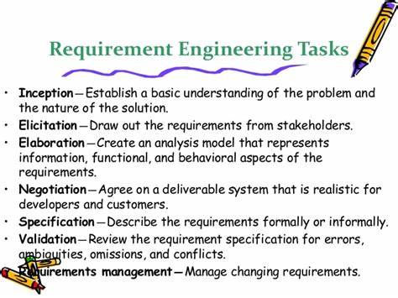

1. **INCEPTION**
   * + Inception means ‘beginning’. It is always problematic for the developer that from where to start.
     + The customer & developer meet and decide the overall scope and nature of the problem.
     + The aim is:

* To have basic understanding of the problem.
* To know the people who will use the software.
* To know exact nature of problem.

1. **ELICITATION**
   * + Elicitation means ‘to draw out the truth from anybody’.
     + It is a task that helps customer to define what is required.
     + Required:

* Problems of volatility:- Meaning of volatility is change from one state to another.
* Problem of scope:- Many times customer states unnecessary project details. These details may confuse developers instead of clarity.
* Problem of understanding: Sometimes both customers and developers has poor understanding of needed things, capabilities & limitations of competing environment and understanding of problem domain.

1. **ELABORATION**
   * + Meaning of elaboration is ‘to work in detail.’
     + Information obtained during inception & elicitation is expanded and modified during elaboration.
     + It is an analysis of modelling activity.
2. **NEGOTIATION**
   * + It is the discussion on financial and other commercial issues.
     + Negotiation function is not unusual for customer to ask for more than that can be achieved, given limited business resources.
3. **SPECIFICATION**
   * + It is final work product produced by requirement engineer.
     + Specification serves as foundation of all requirement of software engineering activities.
     + Describes performance and function of computer-based system and constraints that will govern its development.
4. **VALIDATION**
   * + All previous work completed will be just meaningless if it is not validated against customer requirements or expectations.
     + Requirement validation includes:

* Does requirement violate any system domain constraints?
* All requirements are stated clearly?
* Are requirements misinterpreted?
* Is system requirement irascible to system model?

1. **REQUIREMENT MANAGEMENT**
   * + Requirement management starts with identification. Each and every requirement is assigned an unique identifier.
     + For this traceability table is developed. Each and every traceability table is related to the requirement to one or more aspects of the system or its environment.

* **Inception based questions:**

1. What type of software are you preparing?

Ans. Software regarding Bank management system is being prepared. The major reason to develop such type of software is that nowadays everyone is moving towards digital platform and online Banking has become need for an hour.

1. What are the resources required?

Ans. A good coding team, team that will manage Transactions revolving around customer.

1. How software will be prepared?

Ans. A software will be prepared by firstly providing security to users and then keeping a track of their transaction.

* **Elicitation based questions:**

1. State the features available.

Ans. Many features will be available like Fund transfering, Money withdrawal, loan issue and security maintenance, etc.

1. How will you know that whether user is satisfied or not?

Ans. We will be providing a feedback section where they’ll write their reviews, state their needs and expectations.

* **Elaboration based questions:**

1. What type of modifications will be required?

Ans. Timely updation of products on software is mandatory, reviews should be taken into consideration and changes should be made.

* **Negotiation based questions:**

1. What will be the approximate budget to develop your software?

Ans. It will be in range of 50,000-75,000 and also may vary as per the requirements.

1. What type of work is done according to the given budget?

Ans. Developer need to bear ongoing costs such as website domain and hosting, maintainance, etc.

* **Specification based questions:**

1. How software will work?

Ans. Step 1: Create an account and then login.

Step 2: After logging in, User Can perform various bank related task.

Step 3: task include cash deposit, withdrawal, money transferring and loan issue.

Step 4: perform the transaction and write feedback.

Step 5: feedback will be taken into consideration.

* **Validation based questions:**

1. Is your software secured enough?

Ans. Yes, the software is totally secured.

1. What will be the time to use this software?

Ans. It will be working 24*7*365. Anytime Banking related process can be done.

* **SOFTWARE REQUIREMENT SPECIFICATION(SRS):**
* Software requirement is an official statement of what system developers should implement.
* It should include both: user requirement for a system and a detailed specification of system requirements.
* It is a requirement specification for a software system and show complete description of the behavior of a system to be developed.
* Structure of SRS document:

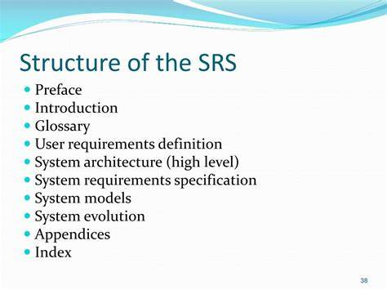

* Features of SRS document:

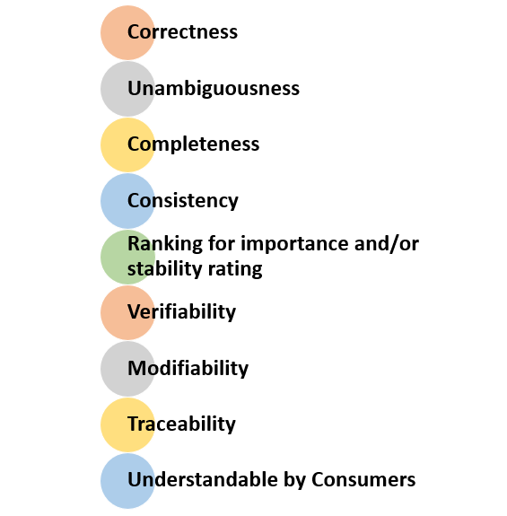

* Need for SRS document:
  + There are 3 major parties interested in a system i.e. the client, the user and the developer. Somehow requirement for the system that will satisfy the needs of the clients and concern of user have to communicate to developers.
  + Helping client understand their own need.
  + Provides reference for validation of final product.
  + A high-quality SRS is a prerequisite to high quality software.
  + SRS determine the requirements of the system and thus it enables the developer to have a rough estimate of total cost.

***SRS DOCUMENT FOR BANKING MANAGEMENT SYSTEM:***

1. INTRODUCTION
   1. **Purpose:**

This document is meant to delineate the features of Online food delivery system, so has to serve as guide to the developers on one hand and a software validation document for prospective client on the other.

This system is for Online food delivery system related tasks and applications is intended to provide complete solutions for vendors as well as customers through a single gateway using the internet. It will enable restaurants to setup online Transactions, customer to browse through the System and perform them online without having to visit the restaurants physically.

* 1. **Scope:**

This system allows the customers to maintain their Account and order food from home.

* 1. **Definition/ Abbreviations:**

SRS- Software Requirement Specification

GUI- Graphical User Interface

Stakeholder- Person who will participate in system. Eg: Customer, Administrator, etc.

OFDS(Online food delivery system)

* 1. **References:**

[www.w3schools.com](http://www.w3schools.com)

Software Engineering: A practitioner’s approach by Pressman, Roger S

1. **OVERALL DESCRIPTION**

The Online food Delivery system application enables Restaurants to provide online services, customers to browse through the system administrator to approve and reject requests for applied order and maintain lists of users.

* 1. **Product Perspective:**

This product aimed toward a person who don’t want to visit the bank as he/she don’t get time for that or might not interested in visiting there and dealing with lot of formalities.

* 1. **Product Functions:**

Some common functions are login, logout, interest rates, Fund Transfer, feedback, visit sites, etc.

* 1. User Characteristics:

User should be familiar with terms like login, register, Order, Transactions etc.

* 1. **Constraints:**

A full fledge internet services is required for OFDS(Online food delivery system).

* 1. **Assumptions & Dependencies:**

It is assumed that the hardware design will work correctly with operating system and developed software. Services will depend on internet connectivity of user.

1. **SPECIFIC REQUIREMENTS**
   1. **Functional requirements:**

This section provides requirement overview of the system. Various functional modules that can be implemented by the system are:

1. **Registration**

If customer wants to Open an Account then he/she must be registered. Unregistered users can’t do the Transactions.

1. **Login**

Customer logins to the system by entering the valid password.

1. **Activities**

The Application has many functional requirements like opening account, depositing/withdrawing funds, updating info, Passing loan to user and deleting an existing Account.

1. **Interface**

The software will have the proper and easy navigation to operate application software. Language will be set for all kind of user.

1. **Database**

The software will have basic connection to database to store the data of users and maintain their records.

1. **Feedback**

Feedback of the staffs can be viewed by the head or manager and appropriate actions will be taken.

* 1. **Non-Functional requirements:**

Following non-functional requirements will be there in insurance to the internet:

1. **Safety**

Secure access to customers confidential data

1. **Availability**

24*7 availability

1. **Updates**

The software updates should be always available on the internet.

1. **Performance**

Better component design to get better performance at peak time.

Flexible service-based architecture will be highly desirable for

future extensions.

Non-functional define system properties and constraints. Various other are: *Security, Reliability, Maintainability, Portability, Reusability, Compatibility, etc.*

* 1. **Performance requirements:**

In order to maintain an acceptable speed at maximum number of uploads allowed from a particular customer as any number of users can access to system at any time. Also the connections to servers will be based on the attributes of the user like his/her location & server will be working 24*7 times.

* **USE CASES:**
* In software and system engineering, a use case is a list of actions or events steps typically defining the interactions between a role and a system to achieve a goal.
* The actor can be a human or other external system. In system engineering use case are used at higher level than within software engineering often representating missions or stack holders goal.
* The detail requirements may then be captured in system modeling language as conceptual statements.
* Use case analysis is an important and valuable requirement analysis technique that has been widely used in modern software engineering.
* Use case symbols:

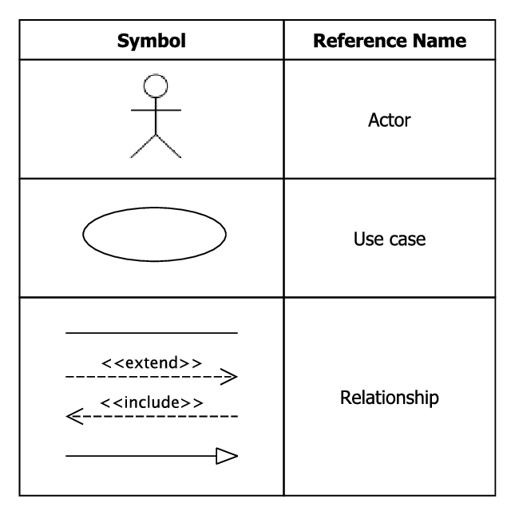

* Advantages of Use Case:

1. Use cases add value because they help explain how the system should behave and in the process, they also help brainstorm what could go wrong.
2. They provide a list of goals and this list can be used to establish the cost and complexity of the system.
3. Use case can serve on basis for estimating, scheduling and validating effort.
4. They are easily traceable.

* **ER DIAGRAM:**
* ER stands for entity relationship. It is a visual representation of data that describes how data is related to each other.
* It is a modeling technique used in software engineering to produce a conceptual data model for an information system.
* Diagram created using ER modeling technique are known as ER Diagrams or ERDs.
* Dr. Peter Chen is the originator of Entity Relationship Diagram
* **Symbols of ER diagram:**

1. Represents an Entity-
2. Represents an Attribute-
3. Represents actions-
4. Links attribute to entity set - ___________________
5. Represents multivalued attribute-
6. Represents weak entity-
7. Connecting lines-
8. Represents process-

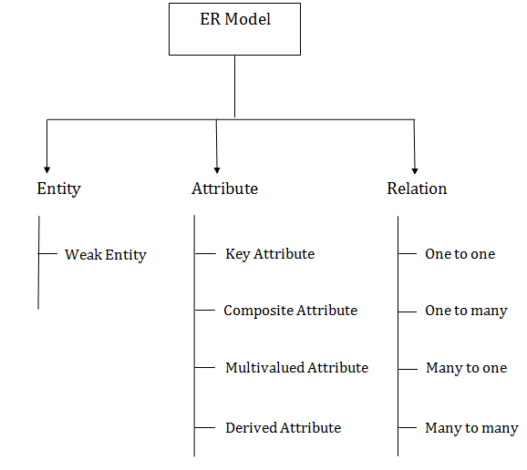

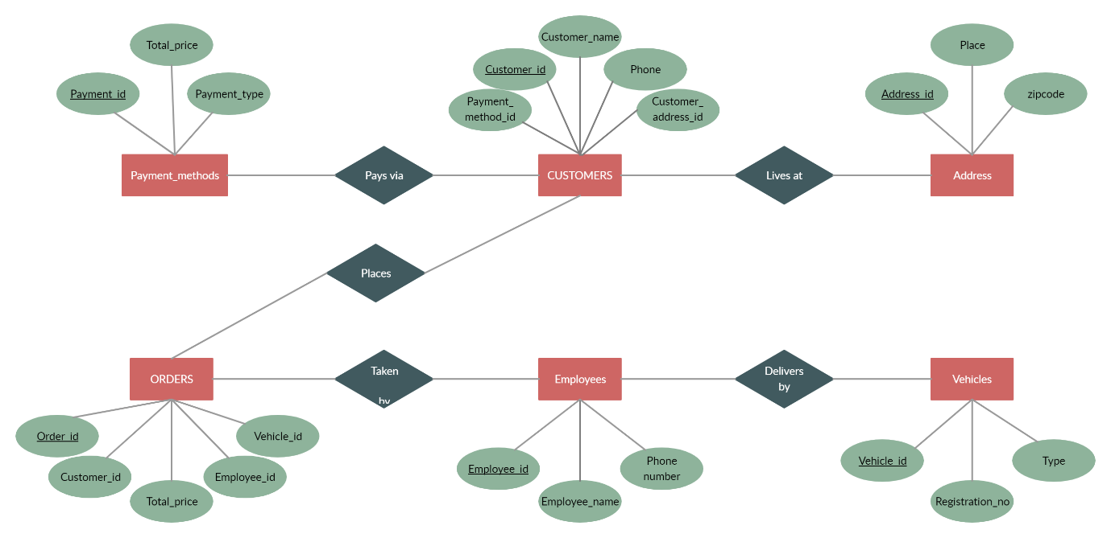

**DATA FLOW DIAGRAM:**

* DFD is an abbreviation for Data Flow Diagram. The flow of data of system or process is represented by DFD.
* It also gives insight into inputs and outputs of each entity and the process itself.
* It provides an overview of:
  + - What data system processes
    - What transformation are performed
    - What data are stored
    - What results are produced
* Components of DFD:

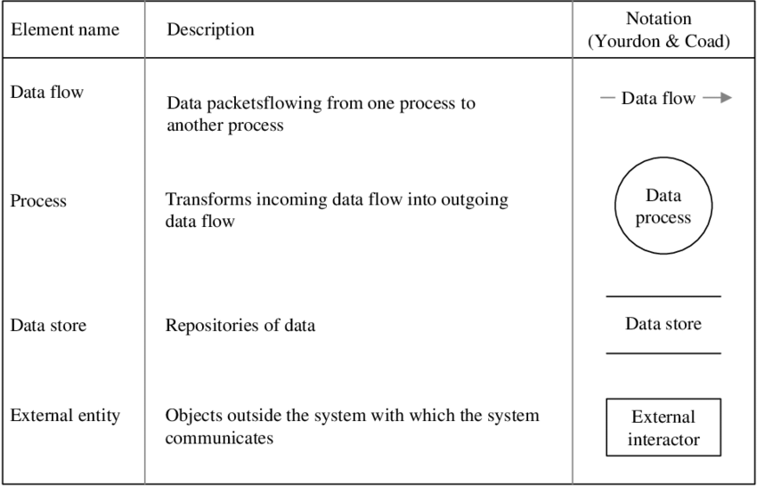

* Levels of DFD:
* Level 0- It represents entire system as a single process and provides an overall picture of the system.
* Level 1- Represents main functions of system and how they interact with each other.
* Level 2- Represents the processes within each function of system.

**LEVEL 0**

At this level, the Input and Output of the system are shown. The system is designed and established across the world with input and output at this level.

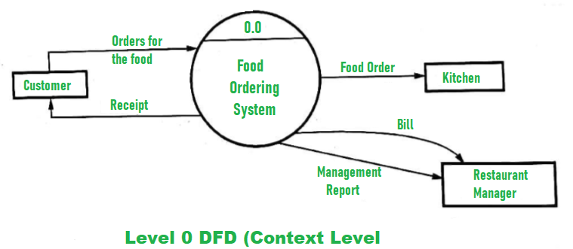

Food Ordering System has the following input:

Food order is input as the customer’s order for food.

Food Ordering System has the following output:

Receipt of the order.

For further processing the order, the food order is passed to the kitchen.

The restaurant manager gets the report of Bill and Management.

For processing the order, process 1.0 is responsible. For food, the housekeeping activities involved are represented by processes 2.0, 3.0, and 4.0.

**LEVEL 1**

The detailed information about daily sold items should be available to create and report management and the list of items that are available ‘in-stock’ should be kept by maintaining the inventory data (describes the records of datasets such as their name, their content, source, many useful information, etc.) at the same time.

Hence, two data stores are used in this level of DFD given below:

* Database of Sold items
* Inventory database

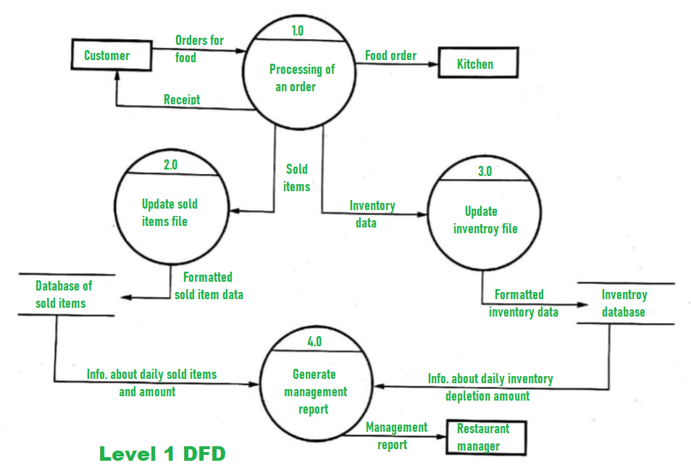

**LEVEL 2**

In the end, with the use of the amount of daily sold items and daily inventory depletion, it is easy to prepare a report of management. Further, the restaurant manager gets this report of management.

Detailed information about “Processing of an Order” is shown below:

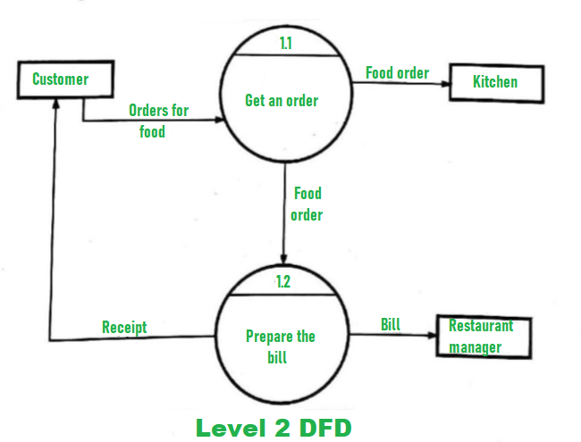

**V. Actual Methodology Followed**

We were assigned with the micro project topic and time was assigned to us to complete the project in 11 weeks. All team members worked together in these 11 weeks together in order to complete this micro project. Data was collected according to our topic. Presentation was prepared, technical report was prepared and then we prepared ourselves to deliver the presentation.

**VI. Actual resources used**

|  |  |  |  |  |
| --- | --- | --- | --- | --- |
| **Sr. no.** | **Name of resources** | **Specifications** | **Qty** | **Remarks** |
| 1. | Computer | i3 – i5 | 1 | - |
| 2. | Windows | 10 | 1 | - |
| 3. | Websites | Geeksforgeeks,tutorialspoint | 1 | - |
| 4. | Images | Bing | 1 | - |

**VIII. Skills developed/ Learning outcomes**

- Derive: Derive different possible solutions creatively.

- Data Collection: Collect relevant data from different sources (books/the internet/the market/suppliers/experts and others through surveys/interviews)

- Designing- Designing microproject with minimum required resources and at low cost.

- Teamwork- Learning to work in team and boost individual confidence.

- Time management- Completion of microproject as scheduled.

- Technical writing- Preparing a report of proposed plan and report.

- Presentation and communication skills: Giving working model presentation of the micro project.

- Confidence: Confidently, answer the questions asked about the project.

- Efficiently gathering details from research papers.

- Writing an assembly language program using procedure

**IX. Applications of this microproject**

* A software engineering project for an online food delivery system can have various applications, including:
* Ordering and payment: The software solution can provide a user-friendly interface for customers to browse menus, select items, and place orders. It can also integrate with payment gateways to enable secure and convenient payment processing.
* Menu and inventory management: The software solution can help manage menus and inventory, enabling restaurants to easily add, remove, or update menu items, and track inventory levels to avoid stockouts.
* Delivery management: The software solution can help manage the delivery process, including assigning drivers, tracking delivery status, and optimizing routes to ensure timely and efficient deliveries.
* Customer management: The software solution can help manage customer data, such as order history and preferences, to enable personalized marketing and promotions.

**Micro Project Evaluation Sheet**

Name:Abdurrahman Qureshi Enrollment no: 2100020112

Name of programme: Computer Engg Semester: 4th

Course title: Software Engineering Code: 22413

Title of microproject: Online Food Delivvery System

Course outcomes achieved:

i. Learned hot to do Software Analysis for the given topic.

ii. Learned how to do System Design for the given topic.

iii. Learned to code sysetematically for the given topic.

iv. Learned to do software testing fot the given code.

v. Learned to do Operation & Maintenance for the given code.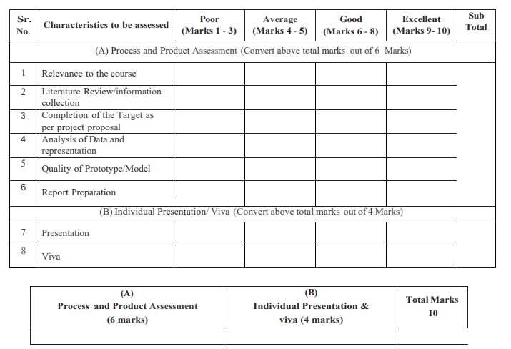

**Comments/Suggestions about teamwork/leadership/interpersonal communication ___________________________________________________________________________ ___________________________________________________________________________**

#### Name and designation of teacher: _____________________________________________ Dated signature: ______________________

**Micro Project Evaluation Sheet**

Name:Ansari Saad Enrollment no: 2100020102

Name of programme: Computer Engg Semester: 4th

Course title: Software Engineering Code: 22413

Title of microproject: Online Food Delivery System

Course outcomes achieved:

i. Learned hot to do Software Analysis for the given topic.

ii. Learned how to do System Design for the given topic.

iii. Learned to code sysetematically for the given topic.

iv. Learned to do software testing fot the given code.

v. Learned to do Operation & Maintenance for the given code.

**Comments/Suggestions about teamwork/leadership/interpersonal communication ___________________________________________________________________________ ___________________________________________________________________________**

#### Name and designation of teacher: _____________________________________________ Dated signature: ______________________

**Micro Project Evaluation Sheet**

Name:Arya More Enrollment no: 2100020097

Name of programme: Computer Engg Semester: 4th

Course title: Software Engineering Code: 22413

Title of microproject: Online Food Delivery System

Course outcomes achieved:

i. Learned hot to do Software Analysis for the given topic.

ii. Learned how to do System Design for the given topic.

iii. Learned to code sysetematically for the given topic.

iv. Learned to do software testing fot the given code.

v. Learned to do Operation & Maintenance for the given code.

**Comments/Suggestions about teamwork/leadership/interpersonal communication ___________________________________________________________________________ ___________________________________________________________________________**

#### Name and designation of teacher: _____________________________________________ Dated signature: ______________________

**Micro Project Evaluation Sheet**

Name:Adnan Kazi Enrollment no: 2100020117

Name of programme: Computer Engg Semester: 4th

Course title: Software Engineering Code: 22413

Title of microproject: Online Food Delivery System

Course outcomes achieved:

i. Learned hot to do Software Analysis for the given topic.

ii. Learned how to do System Design for the given topic.

iii. Learned to code sysetematically for the given topic.

iv. Learned to do software testing fot the given code.

v. Learned to do Operation & Maintenance for the given code.

**Comments/Suggestions about teamwork/leadership/interpersonal communication ___________________________________________________________________________ ___________________________________________________________________________**

#### Name and designation of teacher: _____________________________________________ Dated signature: ______________________